**Name:** Hamed Nasef Mahmoud Aglan

**B.N:** 277

**Date:** 4/6/2020

**Topic:** Artificial Intelligence

**Github link:** <https://github.com/HamedAglan/Artificial-Intelligence-1>

**Github page:** <https://hamedaglan.github.io/Artificial-Intelligence-1/>

**Application brief:**

## Artificial Intelligence (AI)

refers to the simulation of human intelligence in machines that are programmed to think like humans and mimic their actions. The term may also be applied to any machine that exhibits traits associated with a human mind such as learning and problem-solving.

Application Of AL:

the form of AI where programs are developed to perform specific tasks, that is being utilized for a wide range of activities including [medical diagnosis](https://en.m.wikipedia.org/wiki/Medical_diagnosis), [electronic trading platforms](https://en.m.wikipedia.org/wiki/Electronic_trading_platform), [robot control](https://en.m.wikipedia.org/wiki/Robot_control), and [remote sensing](https://en.m.wikipedia.org/wiki/Remote_sensing).

**Screenshots:**

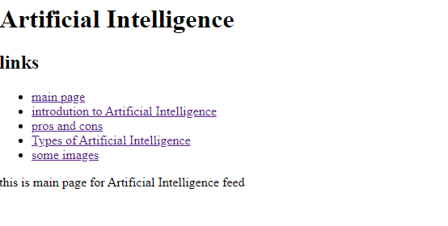

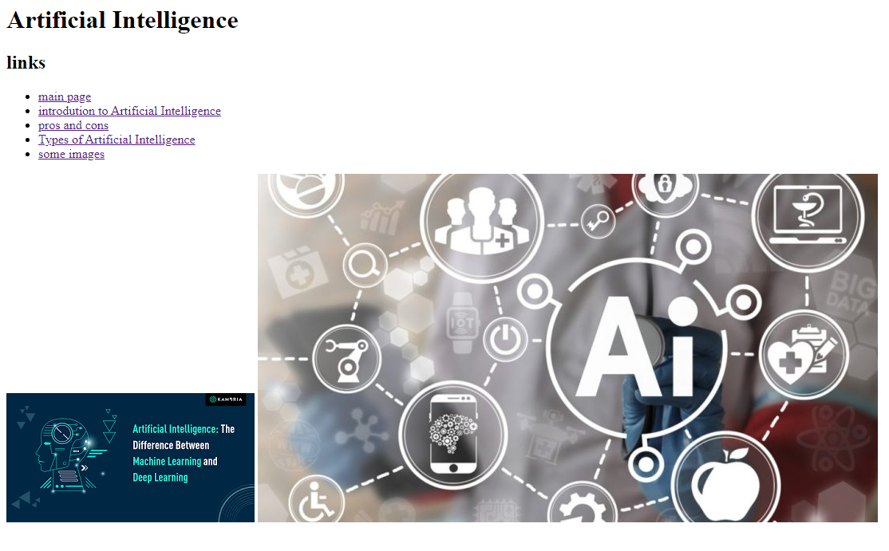

**Source code:**

